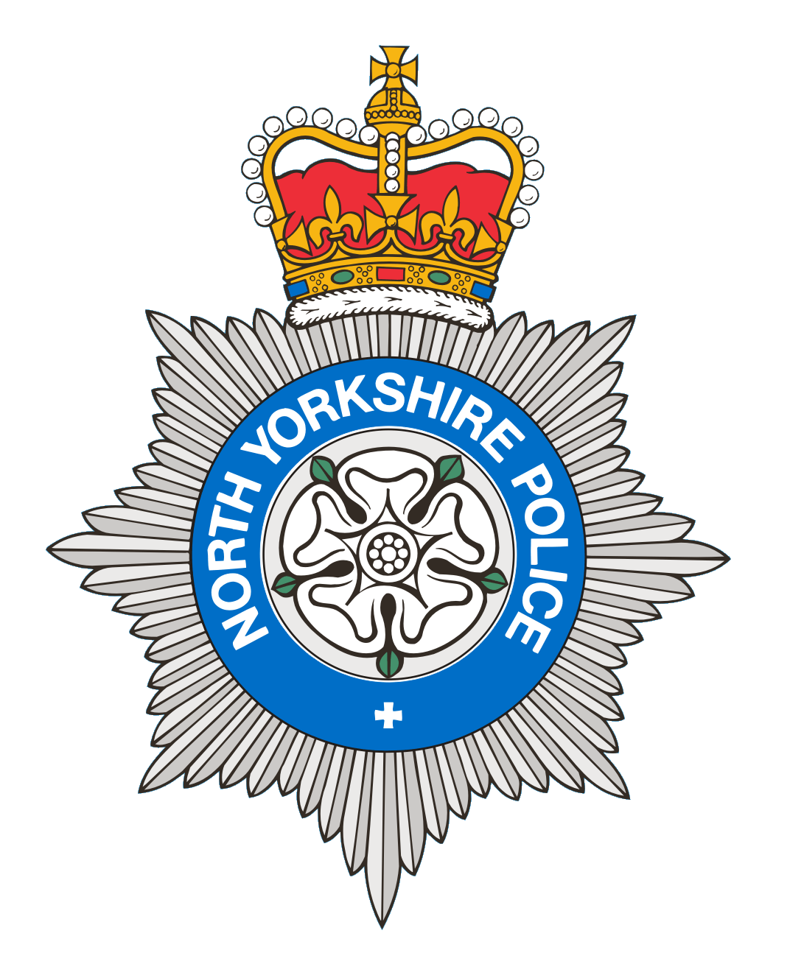
PCSO 3521 Diane Smith
Produced: 20th September 2024
Date of meeting- 13th September 2024

BROUGH WITH ST GILES
PARISH COUNCIL MEETING 13th September 2024
POLICE REPORT

19/07/2024 - 20/09/2024

Please note that under the police crime reporting system, all reports of criminal activity are recorded as crimes. However, if at a later date it is ascertained that no crime has been committed, this will not show on parish council report due to time delay.

Overall reports recorded for this period = 48
For the same period last year = 43

9 Crimes
4 x Violence
4 x Theft
1 x Drugs Warrant executed. Investigation ongoing.
Reported crime for the same period last year = 3

8 Anti-Social Behaviour
7 x ASB Nuisance
1 x ASB Personal
Reports of ASB for the same period last year = 5

10 Road Safety
6 Road Related incidents - 1 drink driving, 2 vehicles seized due to no insurance. 1 vehicle was reported for having a defect. 2 other minor reports.
3 Highway Disruption
1 Road Traffic Collision
Other reports for the same period last year= 5

21 Personal/Safety/Warning Incidents
3 Concern reports.
3 Domestic incident reports.
7 Suspicious reports.
2 Abandoned calls.
3 Administration.
2 Breech of bail reports.
1 Missing report.
Other reports for the same period last year = 30

North Yorkshire Police are promoting our messaging system, please sign up today to:
Community Messaging
North Yorkshire Community Messaging allows members of the public to register to receive alerts, crime notifications and community news from organisations. It is a way of maintaining contact with Neighbourhood Watch and Rural Watch groups. Neighbourhood & Rural Watch have their own database within community messaging for their members.

​You can sign up to receive alerts as a member of the public here:
https://www.northyorkshirecommunitymessaging.co.uk/

If you wish to speak to your local Neighbourhood PCSO you can send an e-mail to PCSO3521 Diane Smith diane.smith@northyorkshire.police.uk phone 101, choose option 2, and follow the prompts.

